📘 Subatomic Nucleus — Extended Technical & Conceptual Documentation

🎯 Purpose of Subatomic Nucleus
Subatomic Nucleus is the central orchestrator layer for managing, composing, optimizing, and evolving Agentic Workflows within enterprise environments. It acts as a Reasoning Core + Process Engine, enabling dynamic multi-agent orchestration across different domains — Legal, Finance, Operations, Reporting, and more.
The mission of the Nucleus is to ensure that every enterprise request passes through a deterministic cognitive pipeline, where Agents are matched, assembled, optimized, and evaluated with traceability, reuse, and performance scoring.

🧠 Key Concepts

🔹 Core Agents
These are domain-specific agents implemented during active development cycles. Each Core Agent exists because a real enterprise workflow required it and has been iterated through live usage.
Standard for Showcasing a Core Agent:
- Origin use-case (Which enterprise request produced the need)
- Domain Scope (Legal, Finance, Reporting, Contract lifecycle, etc.)
- Input Types (Text, PDF, SQL, Spreadsheet, API data, Meeting Transcript)
- Deterministic Template Used
- Subatomic Audit → Execution Trace / Cognitive Pattern Observed
- Version & Iteration Metadata
These Core Agents are production-ready microservices, reusable across workflows.

🔹 Meta Agents
Meta Agents are higher-order agents responsible for managing, orchestrating, and optimizing other agents instead of executing domain tasks directly. They act as control planes for the multi-agent ecosystem and ensure cognitive consistency, maintainability, and strategic evolution over time.
Key Responsibilities:
- Agent Lifecycle Governance → Register, archive, and version every agent introduced into the system.
- Metadata & Embedding Index Management → Track each agent’s capabilities, domain relevance, historical performance, and interaction signatures.
- Agent Discovery & Ranking Layer → Intelligent selection and prioritized activation of agents based on matching scores against cognitive contexts.
- Agent Evolution Orchestration → Trigger prompt refinements, behavioral updates, and pattern reinforcement through continuous learning loops.
- Cognitive Workflow Serialization → Convert active reasoning flows into reusable procedural templates for future instantiation.
- Human-in-the-Loop Reconciliation Layer → Capture human overrides and convert them into long-term agent behavioral adjustments rather than one-time corrections.
- Cognitive Pattern Consolidation → Identify recurring reasoning flows and abstract them into generalized multi-agent workflows for future reuse.
Meta Agents operate above all domain agents, constantly monitoring, adjusting, and improving the entire agentic ecosystem to ensure scalability, coherence, and cognitive efficiency.

🔹 Meta Cognitive Agents
Meta Cognitive Agents do not execute domain tasks directly, but instead manage the cognition lifecycle of all other agents. Their role includes:
- Process Matching & Cognitive Workflow Detection
- Cognitive Pattern Library Management
- Agent Ranking & Retrieval based on Metadata + Embeddings
- Workflow Serialization & Versioned Storage
- Prompt Optimizer → Updating prompts with real-time knowledge retention
Meta Cognitive Agents are self-updating control layers via self-reflection, including the incorporation of human-in-the-loop (HILP) pathways for scaling and maintaining an intelligent multi-agent ecosystem.

🔹 Features (Multi-Agent Capabilities)
These are end-to-end enterprise processes composed from multiple agents:
Feature | Type | Example Output
Contract Review | Core + Meta Composed | Clause breakdown, risk mapping
Contract Comparison | Multi-Agent Hybrid | SAP GTC + Solex vs Customer
Agenda Generation | Finance Domain Set | Age-driven agenda + RMD logic
Field Service Report Compilation | Compliance + Ops Domain | Report from unstructured notes
Each Feature = A multi-agent orchestration pattern that can be auto-built or manually modified.

🔄 Main Interaction Process with Nucleus
- User submits a request
- Process Matching is triggered using:
  - Reasoning Model Architecture (Meta Cognition Layer)
  - Extracts intent, domain, target output pattern
- Discovery Phase (Human-in-the-loop possible) with Meta Agent for Requirement Engineering
- Agent Assignment Strategy:
  - If Agent Catalog < 50 agents → Expand Context, generate workflow on-the-fly via reasoning
  - If ≥ 50 agents → Perform Hybrid Retrieval, comparing step-level needs vs existing Agents in Semantic + Metadata Layer
- Workflow gets generated and can be saved at:
  - User-Level Scope (Reusable personal workflow)
  - Thread-Level Scope (Contextual / project-bound)
- User updates workflow via:
  - Chat-based modification (Inline agent replacement / reranking)
  - v2: React Flow UI for drag & drop Agentic Workflow editing

🧩 Agent Templates & Deterministic Composition
Each Agent must follow strict composable blueprints, ensuring predictable linkage between agents:
Type | Structure Pattern
Knowledge-Based Agent | Input → Tool Calling (optional) → Prompt Injection with Inputs → Result (Pipeline Feed)
Tool-Based Agent | Input → Prompt Injection → Tool Execution → Tool Output (Pipeline Feed)
Hybrid Structured Agent | Input → Reasoning → External Tool Routing → Structured Result
These templates are versioned and stored in a structured DB Schema, enabling:
- Automated migration
- Backward compatibility logic
- Cognitive Workflow consistency during updates

🏗 Agent Management & Catalog Intelligence
- Separate DB Schemas for Meta Agents and Core Agents
- Each Agent has:
  - Type (Domain, Tooling, Reasoning Control, Knowledge Extraction)
  - Sub-Type (API Extraction Agent, PDF Knowledge Extractor, Vector Search Agent, Prompt Synthesizer, Tool Evaluator, etc.)
- Retrieval Layer:
  - Hybrid Search (Embeddings + Metadata Filtering)
  - Re-rank via Cognitive Pattern Similarity Scoring
- Agents stored with:
  - Execution History
  - Performance Metrics
  - Contextual Trigger Mapping (Tracks WHY they were used)

🔧 Tool Calling Layer (Polymorphic / Decoupled)
- All tools follow Liskov Substitution Principle
- Each tool derived from an abstract ToolInvoker class with .invoke()
- External Integrations decoupled via n8n or MCP Tools pipeline:

n8n
- Will be used for most tool integrations with enterprise data.
- Selected because it enables:
  - Performance with a decoupled integration model
  - Data security alignment
- Functions as the default integration layer when dealing with enterprise systems or sensitive data.

MCP Servers
- Will be used for agile data retrieval.
- Chosen when performance is a key priority.
- Applied only when security is not a high priority, as MCP Servers still require standards to handle secure processes before being considered compliant for sensitive data.

- Ensures that agent does not care about tool origin, only about contracted execution interface

🌐 Inputs — Multimodality as Default
Nucleus supports multi-format ingestion:
- Total of 21 standardized loaders
- PDF, DOCX, HTML, XLSX, CSV, SQL, API response, MP3 transcript, Image OCR
- Inputs abstracted into UnifiedInputStream
This allows Agents to treat all formats as cognitive fuel without format-specific logic.

🎯 Prompt Optimizer Layer
Every Agent prompt evolves using:
- Extracted Cognitive Workflow patterns
- Data from User-HITL Interventions
- Embedded Domain-Specific Knowledge Variables
- Context Engineering Principles (Pattern references from Subatomic Audit / Eval Trace)
Prompts become self-tuning, aligning with enterprise specificity (SAP legal clauses, RMD calculation patterns, Tax Code phrasing, etc.)

🧱 Architecture Foundation: CLEAN Principles
- Separation of Domain, Application, Infrastructure, Interface
- Reduces friction for CI/CD scaling of new Agents
- Agent Testing Suites per Agent template are mandatory
- Pull Requests must include:
  - Agent Template Version Tag
  - Migration Script if DB Schema changed
  - Traceable Intent File (Why this agent exists)

🔄 DB Migrations
Every update to Agent/Workflow layer:
- Uses a migration-based delta approach
- This creates:
  - Backup-Version of previous Agent Template
  - Change Log (Who changed, why, linked issue ID)
  - Allows rollback & historical traceability for audits and safety compliance

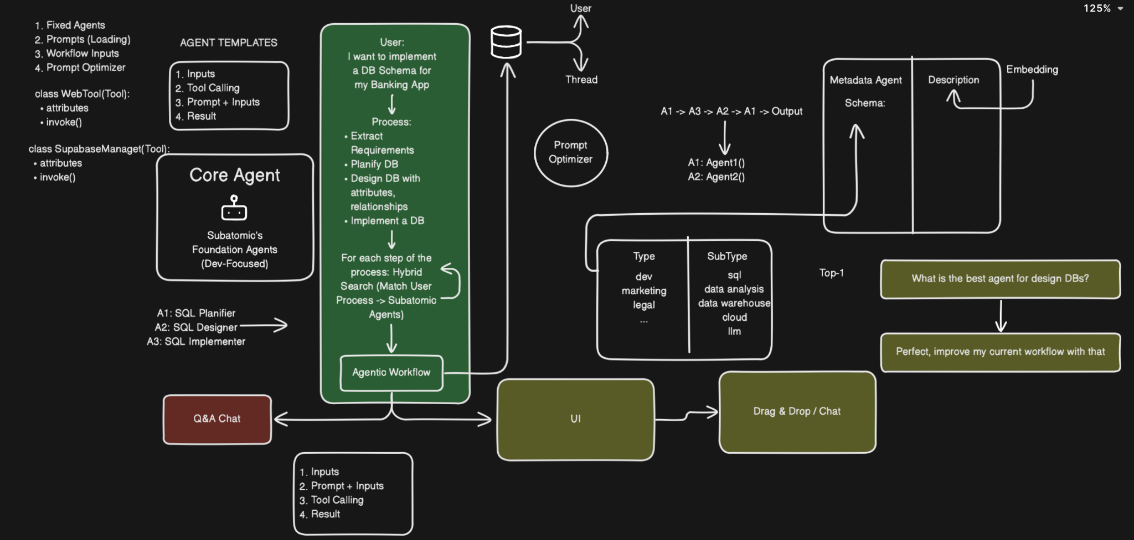
FIRST VERSION OF THE ARCHITECTURE:

